Q2:

The idea behind this task is to build a simulation of an earthquake happening in a platform using Accelerometer. The measurements are roll (rotation of front to back axis) and pitch (side to side axis) which from axis x, y, z. I will represent the motion of roll and pitch in a 3D simulator. The pictures below will show how roll and pitch work. Note that the simulation and the formulas for calculating roll and pitch are taken from Dejan (2019) How to Mechatronics tutorial. Here is how the roll and pitch work in 3D representation.

This is when the platform is stationary, meaning there is no movements.

This is when the platform is in roll rotation or front to back axis.

This is when the platform is in pitch rotation or side to side axis.

If pitch or roll value is more than +-9, there will be warnings.

Q3:

From question 2, if pitch or roll value is more than +-9 alarms will set off. I will be explaining using code.

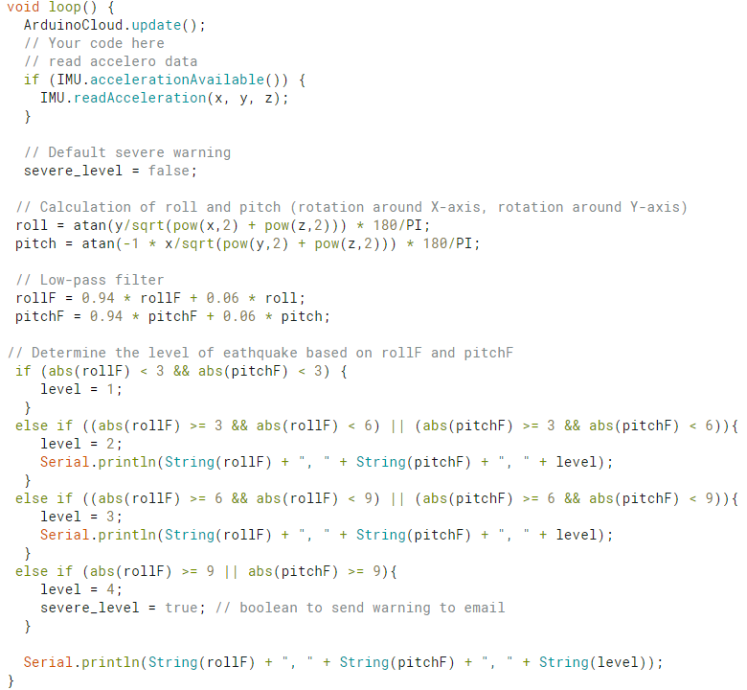

`roll`, `pitch`, `rollF` and `pitchF` are formulas from Dejan (2019) to calculate the pitch and roll measurements. Usually, the measurements of these never exceed 2 if the platform is stationary. I create a variable named `level` to show the different stages of earthquake. Level 1 is absolute value of `rollF` and `pitchF` smaller than 3. Level 2 is absolute value of `rollF` and `pitchF` larger or equal to 3 and smaller than 6. Level 3 is absolute value of `rollF` and `pitchF` larger or equal to 6 and smaller than 9. Level 4 is anything above or equal to absolute value of 9 of `rollF` and `pitchF`. At level 4, I have a variable that will trigger 2 warnings. The Boolean variable will use the trigger function of Arduino cloud to send me a warning email and display the status to true in the dashboard.

Here are the pictures of the two warnings:

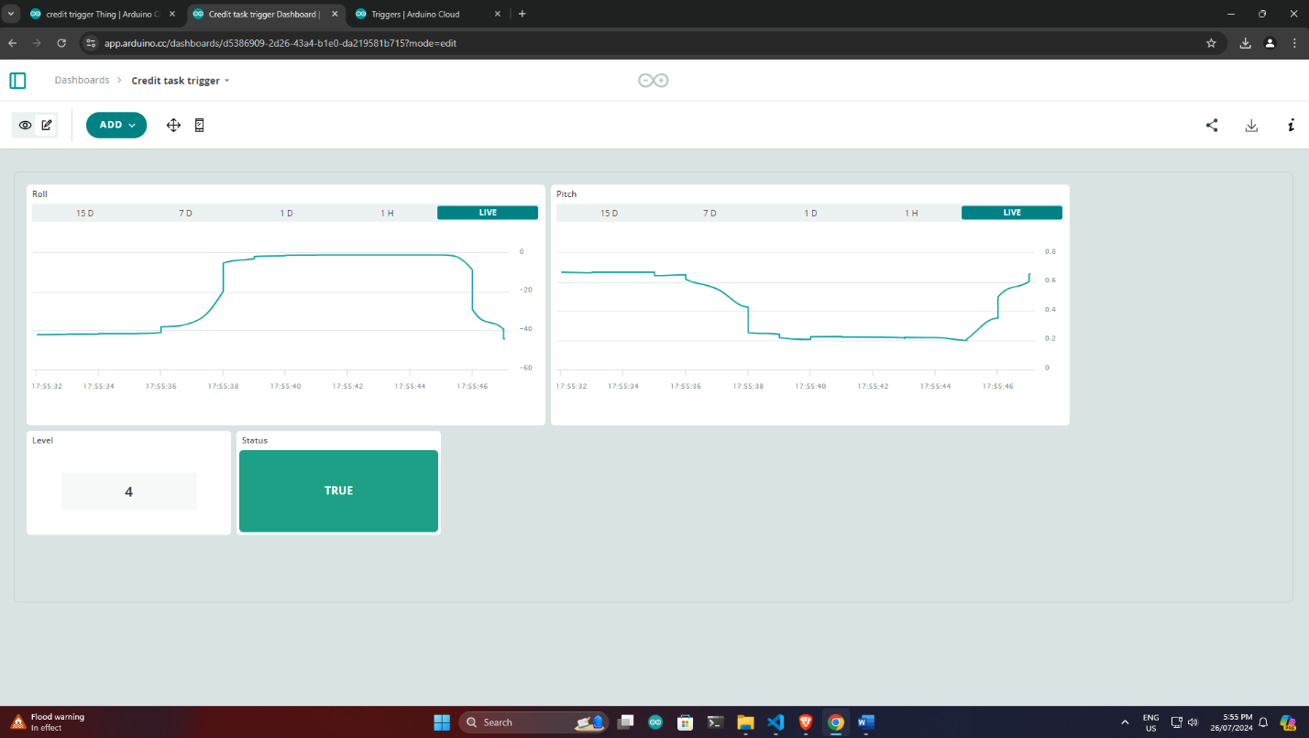

Q4:

<https://www.youtube.com/watch?v=X-UGxDqTn8M>

Q5:

References

Dejan (2019). *How To Track Orientation with Arduino and ADXL345 Accelerometer*. [online] HowToMechatronics. Available at: <https://howtomechatronics.com/tutorials/arduino/how-to-track-orientation-with-arduino-and-adxl345-accelerometer/>.